MDHHS Program Integrity Overpayments Report Pseudo-code
- Query #1: mdhhs_overpayments.sql
  - Temporary Table 1 - #adjusted_max [am]
    - Collecting adjusted claims and ranking by approve_for_accounting_date, descending.
      - claim must have an adjusted line
        - approve for acct dates ranked for all adjusted lines in the reporting period (usually quarter).
          - This will rank #1 the adjustment that happened closest to the end of the quarter.
  - Temporary Table 2 - #claims_pre [pre]
    - Collecting all other claimlines (adjusted or original) from [am] on the lines that are not ranked 1 in previous query, and ranking these in descending order, too.
    - This gives us the state of the claim one step before the final adjustment
  - Temporary Table 3 – Relevant Claims [rc]
    - from [am], the claim id and latest app_for_acct_date are pulled as a fields
      - joined by [pre]– the second latest app_for_acct_date is pulled in
      - this sets the stage for us to compare totals at each stage and therefore identify if an overpayment was adjusted.
  - Temporary Table 4 - #max [max]
    - this is a claims pull for closed claims across the UPHP Medicaid product lines (Medicaid, CSHCS, HMP, MME) that is inner joined by [rc] with the caveat of app_for_acct_date on claim is less than or equal to app_for_acct_date of last adjustment.
      - the sum of the net amount is recorded along with the claim number and app_for_acct_date from last adjustment.
      - this generates one line per claim with the post-adjustment total net amount.
  - Temporary Table 5 - #min [min]
    - this is a claims pull for closed claims across the Medicaid product lines that is also inner joined by [rc] with an alternate caveat (compared to [max]) of app_for_acct_date on claim is less than or equal to the app_for_acct_date ranked number 1 on [pre].
      - the sum of THIS net_amount is recorded along with the claim umber and the #1 ranked (latest) app_for_acct_date from [pre].
      - this generates one line per claim with pre-adjustment total net amount.
  - At this point in the logic, we look to set the stage for comparing the totals between the pre-adjustment and post-adjustment totals we’ve obtained in our [max] and [min] tables.
Pre-Adjust Date and Amt.
Last Adjust Date and Amt.

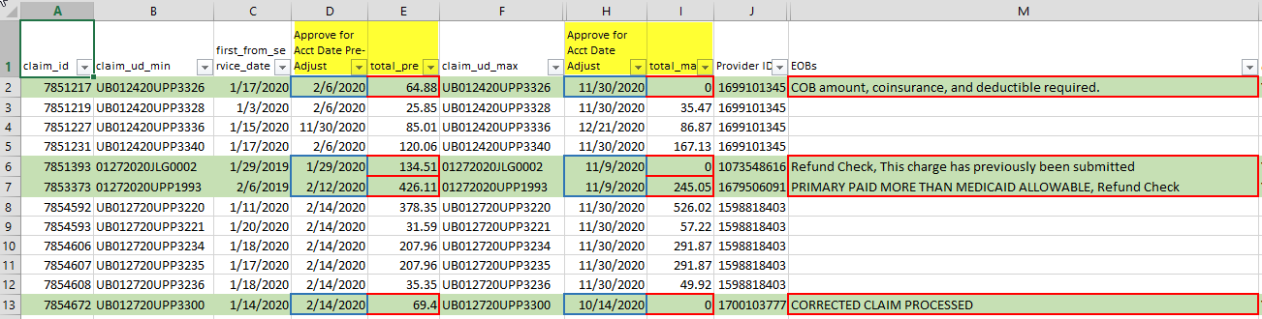
- Since we are dealing with corrected claims in Query #2, these are omitted from Query #1 by identifying all Original Claims and removing them from the above data. (See 2.a. below for that logic.)
    - thinking about this section leads me to believe we may need to remove both the original claim and the corrected claim if they appear in the base overpayment logic that looks at pre and post states of the claim.
- The logic is then formatted for the blue MDHHS program integrity template and a details tab is also produced with the claims detail behind the template entries.

- Query #2: mdhhs_overpayments_ccp.sql (Corrected Claims)
  - This query differs from Query #1 because it returns results which include ONLY corrected claims and their original claim counterparts by using the following logic:
      - the original claim is identified by looking for an eob = CCP, and:
        - the original claim must also have a note of subject = Corrected Claim
        - an additional check is made using the note link table to obtain the corrected claim number(s)* by matching the record_ud of the note link table back to the original claim, listing all record_uds that are not equal to the original claim number
          - it has been found that there may be more than one “corrected” claim tied to an original claim (see UB081420UPP1986)
      - Or, the corrected claim is identified by claim_frequency_code = 7, and the original claim is identified by the claim number in supplemental info’s Original Ref Number field.
      - Original Claim sum of amount paid and Corrected Claim sum of amount paid are bumped up to each other and if Corrected Claim is less than Original Claim then an overpayment is identified.
    - this logic is then formatted for the MDHHS template and a details tab produced
- Query #3: mdhhs_overpayments_recovery.sql (Recovered Claims)
  - This query looks for claims with certain note subject and note status combinations.
    - Query #3 uses the notes area of PCM to identify any claims with certain category and status combinations
      - Claims that have a note with [Refund] or [Auto Recovery] subject AND a status of either [Active] or [Routed].
    - Once these Recovered claims are identified, similar demographic compared to Queries #1 and #2 are brought in.
    - Then, this logic is then formatted for the MDHHS template and a details tab produced
      - note that no monetary fields are populated in this data, as it was originally decided to leave it out. However, after review, Cheryl decided it needs to be in there. (this is stated in the workfront ticket by Cheryl, but has yet to be written into the report).
      - note also, this tab may contain claims that appear from logic associated with Query #2, if the note criteria exists for Query #3 logic.
        - see claim # UB081420UPP1986
        - contains both note logic criteria to fall into Query #2 (corrected claim notes) and also Query #3 (refund note which is active).
          - is there a preferred treatment of claims that appear in both the corrected claims logic and recovery logic?

- End of Pseudocode -

